Chapter 7, Problem 2.

Find the time constant for the RC circuit in Fig. 7.82.

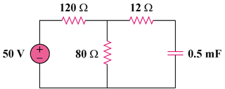

200 mF

Figure 7.82
For Prob. 7.2.

